Update of the SATELLIT. File and the ANTEX (v1.3) Converter, Consideration of Receiver Antenna Radome Codes

Contents

1. Introduction 2
1.1. Files Available for Download 2
1.1.1. Files available from IGS 2
1.1.2. Files available from CODE/AIUB 3
1.1.3. Antenna Information for Newly Launched Satellites 3
1.2. Handling of Receiver Antenna/Radome Code Combinations by the IGS 4
2. How to Update Your Software Version 4
2.1. Software Update 4
2.2. Recommended BPE Update 4
3. Upgraded ANTEX Converter PHCCNV 5
3.1. General Description 5
3.1.1. Input and Result Files 7
3.1.2. Program Output 7
3.1.3. Warning and Error Messages 7
3.1.4. GLONASS Receiver Patterns 8
3.1.5. Model Name for SINEX 8
3.1.6. Receiver Antenna Number 8
3.2. Examples 9
3.2.1. Update of (Currently Used) Bernese PCV File 9
3.2.2. Creation of a Completely New Bernese PCV File from an ANTEX File 9
3.2.3. Enlargement of the Bernese PCV File with Missing Antenna Radome Combinations 10
3.2.4. Elevation Dependent PCV only 11
3.2.5. Merging of Individually Calibrated Antennas 11
3.2.6. Conversion of a Relative to an Absolute Bernese PCV File 11
3.2.7. Handling of Antennas Without Radome Code 12
3.3. Routinely Running PHCCNV 13
3.4. Problematic Antenna Radome Combinations in Relative Case 13
4. How to Switch to the New File Formats 14
4.1. Switch from Currently Used Old PCV File to New Relative File 14
4.2. Switch from Relative Files to Absolute Files 15
4.3. Routinely Updating Phase Pattern File 17
4.4. Summary of File Names 17

Bern, 28-June-2006

Introduction
Absolute antenna phase patterns, e.g., from robot calibrations are getting available. When using absolute antenna PCV (Phase Center Variations) in regional networks it is necessary to use absolute calibrations for satellite antennas, too. Within the IGS such patterns were computed for the active satellites and are made available. A new version of the antenna information exchange format ANTEX, version v1.3, was developed for this purpose. The IGS plans to perform the switch to absolute antenna patterns in autumn of this year (2006), together with the switch to ITRF2005.
The planned changes concerning the use of the antenna models within the IGS include:
- absolute Phase Center Variations (PCV) for receiver antennas,
- use of nadir dependent PCV for the satellite antennas (one common nadir dependent PCV for each block, individual Z-antenna offsets for each satellite),
- consideration of the receiver antenna radomes as far as the antenna radome combination has been calibrated.
The first two changes dependent on each other: with absolute receiver antenna patterns, absolute satellite antenna patterns have to be used, too.
Because of the upgraded version of ANTEX and the upcoming absolute antenna models in the IGS, some small but important changes have to be done by the users of the Bernese GPS Software.
After providing some general information this README first lists the necessary steps for updating your Bernese GPS Software version (Section 2), gives then a detailed description of the new ANTEX converter including a number of useful examples (Section 3), and finally lists the steps that are necessary to switch to the new file formats and, later, to absolute phase patterns (Section 4).
Note that until the new IGS absolute antenna model is officially adopted, there is no need to apply the changes described in this readme file. The changes are, however, necessary in order to use the upgraded ANTEX converter. In addition it is a good preparation for switching to the upcoming absolute antenna model.

Files Available for Download

Files available from IGS
For the planned changes a new absolute ANTEX file is already available from the IGS at URL: ftp://igscb.jpl.nasa.gov/pub/station/general/pcv_proposed/
(see IGS Mail http://igscb.jpl.nasa.gov/mail/igsmail/2006/msg00041.html)
filename: igs05_wwww.atx (e.g., igs05_1365.atx)
The "wwww" indicates the GPS week of the creation of the file. More updates of the file are likely to be issued, e.g., when a new calibrated antenna radome combination is added.
The information concerning absolute antenna phase patterns were compiled by Ralf Schmid at TUM into one ANTEX file on behalf of the IGS.
A relative ANTEX file, igs_01.atx, is available at URL: ftp://igscb.jpl.nasa.gov /pub/station/general/ containing the same information as igs_01.pcv.

Files available from CODE/AIUB
From AIUB/CODE's anonymous ftp server (URL: http://www.aiub.unibe.ch/ download/ BSWUSER50/GEN) several files are available for supporting the switch to the new format as well as the maintenance of the corresponding files by the user. These files are
- PHAS_COD.xxx that contains the phase center information of the antennas processed by CODE, and
- SATELLIT.xxx that contains satellite-specific information, in particular satellite-specific antenna offsets that need to be consistent with the corresponding satellite antenna phase patterns.
The extension xxx of the above files is
- xxx = I01 for files containing relative antenna information based on the IGS ANTEX file igs_01.atx,
- xxx = I05 for files containing absolute antenna information based on the IGS ANTEX file igs05_wwww.atx.
For the switch to the new file formats and to absolute antenna phase patterns you have to download the satellite information files. You may also use CODE's phase pattern files as long as you added no additional antennas to your Bernese PCV file. It is recommended to use a similar naming convention for your files, i.e., indicating the PCV model type with the extension.
It is, however, recommended to use the upgraded ANTEX converter to generate your own Bernese PCV files (see Section 3). The converter allows you to transfer information for your antennas that you added to your current Bernese PCV file to the new Bernese PCV file.
IMPORTANT: Satellite information and phase pattern files form entities that have always to be used together throughout your processing in order to guarantee a consistent use of satellite antenna offsets and patterns. Make sure to never mix files with extensions *.I01 and *.I05.
Two additional files are routinely made available by AIUB/CODE that support you in including the information for new satellites, see following Section 1.1.3.

Antenna Information for Newly Launched Satellites
The new Bernese PCV files require entries for all satellites. In order to make corresponding information available before tracking data of brand new satellites gets available, AIUB/CODE maintains two ANTEX files (I01.ATX and I05.ATX) and makes them available at URL: http://www.aiub.unibe.ch/download/BSWUSER50/GEN or ftp://ftp.unibe.ch/aiub/ BSWUSER/GEN.
At the time of a satellite launch no estimated satellite antenna offsets are available for this satellite and the corresponding entry is missing in the official ANTEX (e.g.; igs05_1365.atx) as well as in the Bernese PCV file. Without this entry in the Bernese PCV file any further processing will be aborted.
The ANTEX files (I01.ATX and I05.ATX) provided at AIUB's anonymous FTP server contains mean values of the same satellite type for a newly launched satellite. Apart of values for new satellites, this ANTEX file is identical to the official ANTEX file. After estimation of official satellite antenna offsets the IGS distributes an updated ANTEX file. From that moment on the ANTEX file at our anonymous FTP will again be identical to the official ANTEX file from IGS.

Handling of Receiver Antenna/Radome Code Combinations by the IGS
Note that with the change within the IGS, antenna radome codes will be consequentially used (radome code in Bernese GPS Software = last four characters of antenna name, e.g., NONE, DOME, SNOW, etc.). The ANTEX files listed above do, however, not contain all possible antenna radome combinations. For missing combinations the IGS decided to copy the values of the same antenna without radome, e.g., values for
"AOAD/M_T DOME" copied from "AOAD/M_T NONE".

How to Update Your Software Version

Software Update
The Bernese GPS Software, Version 5.0, requires only a few small modifications to cope with the foreseen changes concerning absolute phase patterns. Program PHCCNV that converts files from ANTEX v1.3 to Bernese formatted PCV files needs to be updated. In addition an update of the satellite information file is necessary. The update of four subroutines (READSIN.f90, SINSTORE.f90, RDSTACRX.f90 and CHKSIN.f90) of ADDNEQ2 is needed for a correct consideration of receiver antenna radome codes. Because of the increased number of antennas the MAXRCV parameter in GPHECC.f needs to be increased.
To activate the changes for correct consideration of receiver antenna radomes and to activate the updated program PHCCNV the following step has to be performed:

- Update your software to the current release level (at least “27-Jun-2006”). Follow the instructions in BSW Mail #0215 and URL: http://www.bernese.unibe.ch/ support.html to run the update tool.

This update includes several bug fixes and improvements that were implemented since the previous release “09-Mar-2006”. Follow all instructions during the update process. Do not forget to finalize the update process by updating the program panels PHCCNV.INP and ADDNEQ2.INP in the directory “$U/PAN” (%U%\PAN for windows) resp. the BPE option directories $U/OPT/* (%U%\OPT\* for windows).
You may use the menu: Configure >Update input files.

Recommended BPE Update
In order to allow for an efficient switch between relative and absolute PCVs in the BPE it is recommended to use a BPE variable V_PCV for the file extensions: Change the names of the satellite information file in all program panels of the option directories ($U/OPT and $X/OPT) from SATELLIT. to SATELLIT.$(PCV) and of the Bernese PCV file from PHAS_IGS.REL to PHAS_ccc.$(PCV). The string “ccc” is an arbitrary three character abbreviation, e.g., identifying your institution.
You may use the menu: Configure >Change general options.
Define the V_PCV variable in all PCF-files by including the line:
“V_PCV GNSS PCV MODEL I01” (or “I05”) in the last section.
By using a variable for the file extension you are prepared for any further update of the antenna model.

Upgraded ANTEX Converter PHCCNV

General Description
With the new PHCCNV version you will be able to:

- update your (old) Bernese PCV file containing old satellite antenna names and no receiver antenna radome codes,
- update the Bernese PCV file in case of new PCV calibration values,
- prepare a completely new Bernese PCV file (relative or absolute) from ANTEX,
- convert a relative Bernese PCV file (with all included antennas) to an absolute Bernese PCV file,
- merge new or individually calibrated antenna patterns from (relative or absolute) ANTEX to your existing (relative or absolute) Bernese PCV file,
- add patterns of antenna radome combinations that are not included in ANTEX to the Bernese PCV file.

Note that the consideration of radome codes is a must for the upgraded ANTEX converter. In addition, the converter requires the new SATELLIT.xxx files made available at the anonymous ftp server (ftp://ftp.unibe.ch/aiub/BSWUSER50/GEN or URL: http://www.aiub.unibe.ch/ download/BSWUSER50/GEN). Be sure to use the correct version ( *.I01 = relative or *.I05 = absolute), depending on the desired output PCV file type.
The panels of the updated program are similar to those of the old version. Just two additional input files (“Bernese PCV file” and “Station information file”) and three new options ("Conversion of PCV file", "Consider antennas without radome code" and "Elevation dependent patterns only") were added. A description of the options can be found in the online help or below in the examples.
Depending on the input files, the program handles relative or absolute antenna models. Furthermore the conversion from relative to absolute antenna model is possible. In that case, the program checks whether the elevation depended corrections for, e.g., AOAD/M_T antenna numbered with 999999 (second entry in antenna number range) are zero or not. In any case, check the detailed program output carefully in order to verify that the information for all antennas was properly handled and that the output PCV file is ready for use.
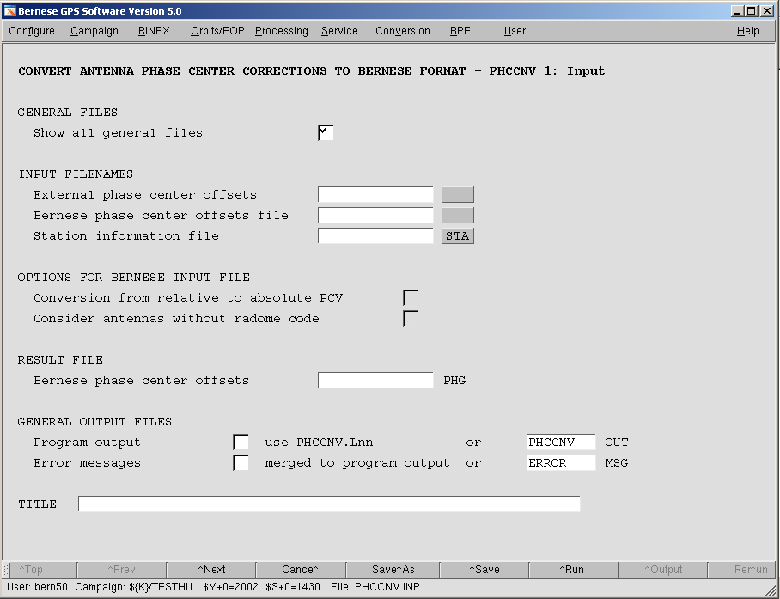

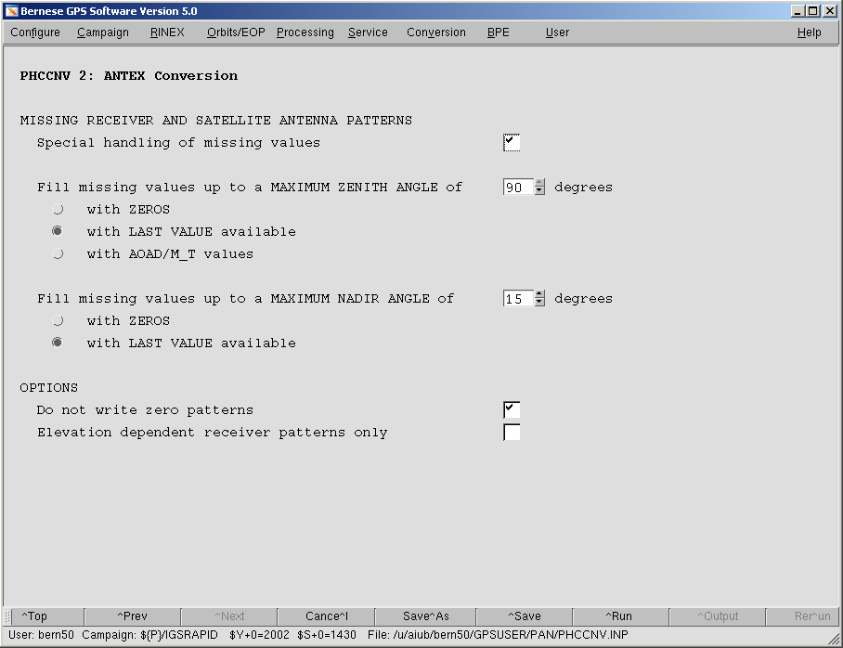

Input and Result Files
The three possible input files are read from different directories. The external phase center offset file (ANTEX file) has to be stored in the OUT directory of the campaign. The input Bernese PCV file is read from $X/GEN and the station information file is read from the STA directory of the campaign.
The resulting Bernese PCV file is stored in the OUT directory of the campaign and is labelled with the extension .PHG. Please verify the content of the created PCV file before copying it to the $X/GEN directory. In addition, you should rename the extension from PHG to I01, or I05. We recommend to use a consistent file naming convention indicating the PCV model, e.g., PHAS_ccc.I01 for relative files based on the relative IGS01 PCV model and PHAS_ccc.I05 for absolute files based on the absolute IGS05 PCV model. The string “ccc” is an arbitrary three character abbreviation, e.g., identifying your institution.

Program Output
The program output provides a detailed summary of the conversions performed. The first section lists all satellite antennas from the satellite information file as well as corresponding information from the ANTEX file. A second section deals with all other antennas and gives the information where the offsets and pattern values are taken from (ANTEX or input Bernese PCV file or directly converted to absolute). The two sections are always provided. Additional sections depend on the selected options and are self-explanatory.

Warning and Error Messages
The program provides detailed warnings and error messages in case of possible problems. Please be aware of the fact that some warning messages appear even in regular program runs.
The program, e.g., generates a warning message for each satellite included in the satellite information file for which no antenna is available in the ANTEX file. Since for most GPS Block I and older GLONASS satellites no absolute offsets and patterns are available, you may ignore the corresponding warnings as long as you do not process data from these satellites. However, do not overlook new satellites that are not yet included in ANTEX (see also Section 1.1.3).
Further warning messages are issued if you select an input Bernese PCV file with missing antenna radome codes for one or several antennas. Depending on the setting of "Consider antenna radomes without radome code", missing radome codes are substituted with a string '????' in the output PCV file or these antennas are not written at all to the output PCV file. A similar warning is issued if a station information file with missing antenna radome codes in section TYPE 002 is selected (see also Section 3.2.3). For that reason, please add first the correct antenna radome codes in the input Bernese PCV file and in the station information file before executing the ANTEX converter.
Error messages are generated if you try to combine, e.g., an absolute input Bernese PCV file with a relative ANTEX file or a relative ANTEX file with an absolute satellite information file. In this case no result file will be written. You have to rerun the program with the correct combination of files and options.
If you have changed the satellite antenna names in your satellite information file, you have to ensure that the characters 11 to 16 of the satellite antenna name in the satellite information file are identical to the characters 7 to 12 of the corresponding satellite antenna name in the ANTEX file. Otherwise the satellite antennas are not included in the Bernese PCV file and the program issues a warning message. To avoid problems, we advise to use the satellite antenna naming of the provided satellite information files SATELLIT.I01 and SATELLIT.I05.

GLONASS Receiver Patterns
GLONASS satellite antenna PCVs were estimated based on the assumption that all receiver antenna PCVs for GLONASS frequencies are equal to those of GPS frequencies. However, studies have shown small differences between receiver antenna PCVs for the two satellite systems. To be more precise, for the different frequencies, the IGS will eventually make ANTEX files available that include GLONASS-specific receiver antenna information.
Since the Bernese GPS Software V5.0 handles only one PCV per receiver antenna and frequency, non-GPS patterns found in the input ANTEX file remain disregarded by the converter and just GPS patterns are written to the output Bernese PCV file. This approach is justified by the relatively small GPS-GLONASS pattern differences and the fact that corresponding GNSS receiver antenna calibrations are currently available only for selected antennas.

Model Name for SINEX
The model name ("IGS_01" for relative files or "IGS05_wwww" for absolute files) is automatically included in the title line of the output Bernese PCV file. The program ADDNEQ2 reads this line when an input Bernese PCV file is specified in panel "ADDNEQ2 1.1: General Files" and if an output SINEX file shall be written. It extracts the PCV model name from the characters 13-22, if characters 1-12 of the title string are "MODEL NAME", and includes it in the SINEX section "SITE/GPS_PHASE_CENTER". Be sure to select the same PCV file in program ADDNEQ2 as you used in program GPSEST.
If the title line in the input Bernese PCV file contains the model name, the name is replaced by the model name of the ANTEX file if characters 1-3 and 6 of the model are equal (matching, e.g, "IGS??_" assuming that the Bernese PCV file is updated with a new IGS PCV model). If you use your own model you should use a different convention for the model name, e.g., "LPT05". If desired, the converter's behaviour of modifying the title line may be adapted to your needs in program PHCCNV.f (close to line 1520).
In any case, check the given model name in the title line of the output Bernese PCV file.

Receiver Antenna Number
In the Bernese Software it is mandatory to use numeric antenna numbers for all receiver antennas. For a generic antenna (no individual calibration available) the antenna number is set according to the entry in the station information file to 999999 when importing the RINEX observation files. In the Bernese PCV file ranges are specified for antenna numbers. The antenna with the range from 0 to 999999 is the generic entry. Individually calibrated antennas are explicitly numbered, e.g., from 317 to 317. The Bernese software uses the first matching entry for a receiver antenna. Individually calibrated antennas have thus to be listed above the generic antenna entry. The converter takes care of this fact and sorts entries of equal antenna types accordingly.

Examples
The following examples describe the handling of the most important conversion scenarios.

Update of (Currently Used) Bernese PCV File
One of the new features of the program is the possibility to update a Bernese PCV file with information from ANTEX. This is the most important step commonly used by the users and in addition it corresponds exactly to the procedure to be applied when a new ANTEX file is distributed by the IGS. Apart from the ANTEX file (e.g., I01.ATX), an existing Bernese PCV file has to be selected in the field "Bernese phase center offsets file" as input. The program will update all antenna patterns in this file that are available in the ANTEX file. All other antennas (incl. SLR, etc.) will be adopted from the old phase file.
Moreover, please specify the correct satellite information file in panel “PHCCNV 1.1: general files” (SATELLIT.I01 for this example).
Note that it is only possible to update the Bernese PCV file containing old satellite antenna names, if a complete ANTEX file including receiver antennas as well as GPS satellite and GLONASS satellite antennas is used (e.g., I01.ATX or I05.ATX).
The new Bernese PCV file is stored with extension “.PHG” in the OUT directory of the current campaign. After verification of the converted PCV file, copy it into the $X/GEN directory (%X%\GEN for windows) and rename it if you want.

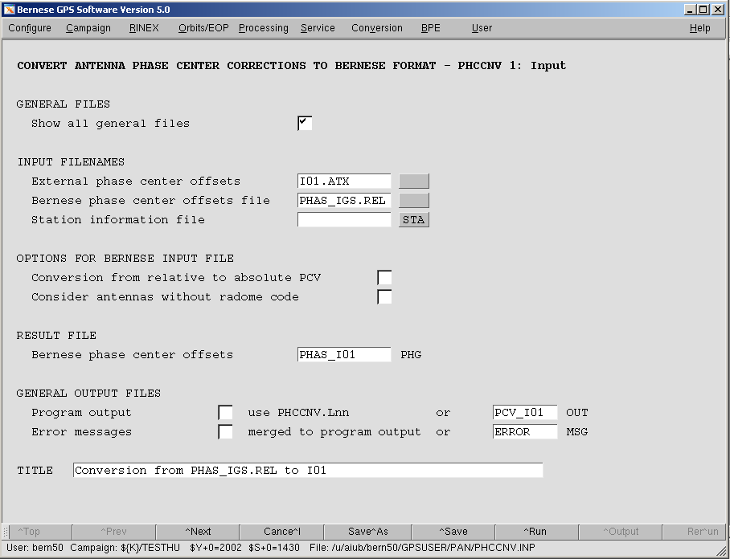

Creation of a Completely New Bernese PCV File from an ANTEX File
The basic function of the program is the conversion of an ANTEX file into a completely new Bernese PCV file. Select the name of an ANTEX file (e.g., I05.ATX) in the field "External phase center offsets". Leave the other two input fields blank. Finally, specify the compatible satellite information file in panel “PHCCNV 1.1: General Files” (SATELLIT.I05 for this example). The resulting file is a Bernese PCV file that only contains the information from the ANTEX file.
Note that the specification of an ANTEX filename is always necessary for a PHCCNV program run.

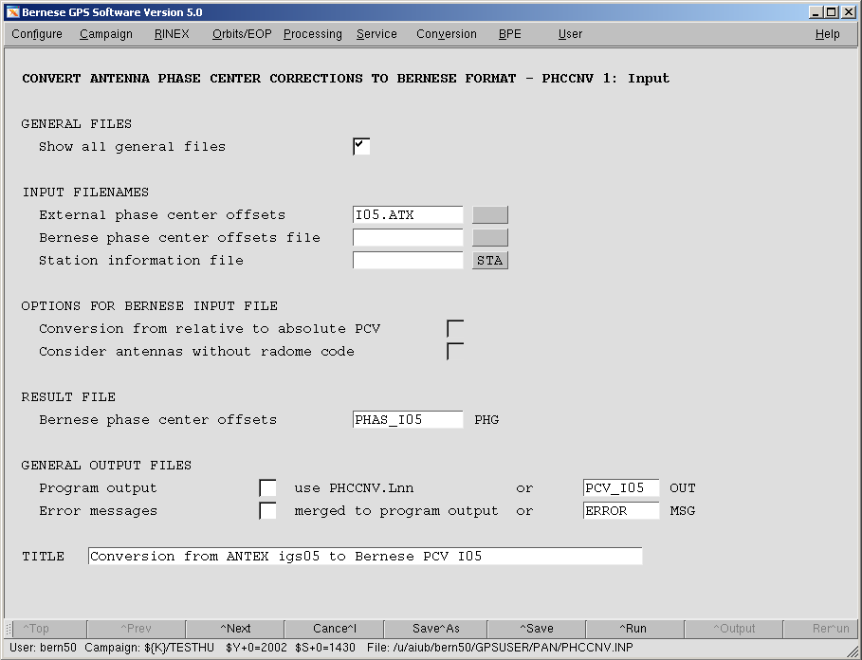

Enlargement of the Bernese PCV File with Missing Antenna Radome Combinations
The absolute IGS ANTEX file does not contain all antenna radome combinations, e.g., “AOAD/M_T DOME”. After a “one-to-one” conversion from the ANTEX into the Bernese PCV file these antenna radome combinations are missing for analysis of a network that includes these specific combinations. Using PHCCNV, it is possible to extend the output Bernese PCV file with all necessary antenna patterns by selecting a station information file (e.g., EXAMPLE.STA) in the field "Station information file". This file has to be maintained by the user and should contain at least all stations used within the network and correct antenna radome codes for all used antennas.

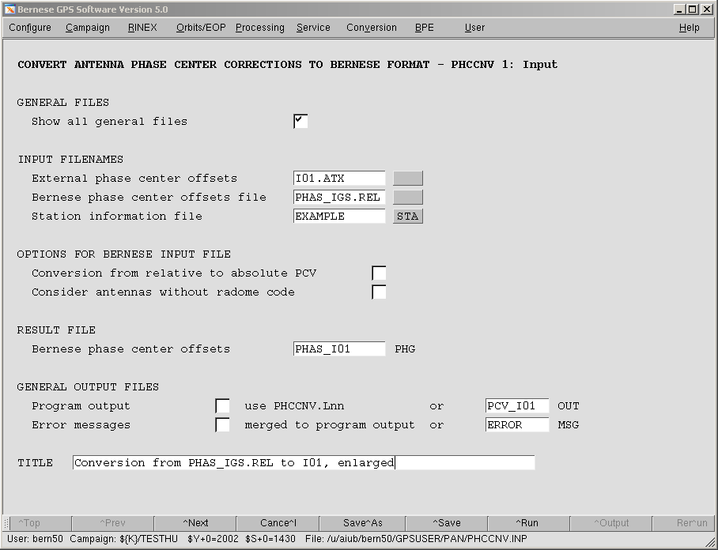

Include in the second section (TYPE 002) of the station information file the correct receiver antenna/radome code combination (radome code = last four characters of antenna name). Use either an ASCII editor or the menu: Campaign >Edit station files >Station information.
For antennas included in the station information file but not included in the ANTEX file, the program copies then the values from the corresponding antenna with radome code "NONE" inline with IGS practice, see Section 1.2 (e.g., values for "AOAD/M_T DOME" are adopted from "AOAD/M_T NONE").

Elevation Dependent PCV only
If you wish to get only elevation dependent receiver antenna patterns from ANTEX, check the box "Elevation dependent receiver patterns only" in the panel “PHCCNV 2: ANTEX Conversion". By selecting this option the program converts only the NOAZI line in the ANTEX file.
Note that this works exclusively for the antennas converted from ANTEX file. Antennas from an input Bernese phase file that are not included in ANTEX will not be reduced.

Merging of Individually Calibrated Antennas
It is possible to merge individually calibrated antennas from an ANTEX file to an existing Bernese PCV file. For an ANTEX file that only contains the individually calibrated antenna with an individual serial number, the program merges the antenna into the selected Bernese PCV file. The corresponding ANTEX file and the Bernese PCV file have to be selected (see Section 3.2.1).
Note that an individual serial number in ANTEX has to be numeric and in the range of 1 to 999998, otherwise the serial number is set to zero and the converter overwrites the generic entry of this antenna in the output Bernese PCV file.
Also note that the selected Bernese PCV file must contain the new satellite antenna names. If it is desired to merge a specific antenna to the currently used Bernese PCV file, the update step described in Section 3.2.1 has to be done first.

Conversion of a Relative to an Absolute Bernese PCV File
Another new feature is the conversion of a relative to an absolute Bernese PCV file. To activate this option, select an absolute ANTEX file (e.g., I05.ATX) and a relative Bernese input PCV file and mark the checkbox "Conversion from relative to absolute PCV". The resulting Bernese PCV file will then contain all antennas from ANTEX as well as all converted antennas from the input Bernese PCV file that are not included in the ANTEX file. The expansion of the Bernese PCV file with missing antenna radome combinations as described in Section 3.2.3 is also possible for the conversion.
The conversion is performed by adding the absolute pattern of the reference antenna “AOAD/M_T NONE” to the relative patterns of antennas that are not included in ANTEX. The absolute ANTEX file must contain the mentioned reference antenna.
In any case, the program checks whether a conversion is allowed. If either the input ANTEX file contains relative patterns or the input Bernese PCV file contains absolute patterns the program stops execution with an error message. Similarly, the program stops if the conversion checkbox remains unmarked, but the two input files are of different type.

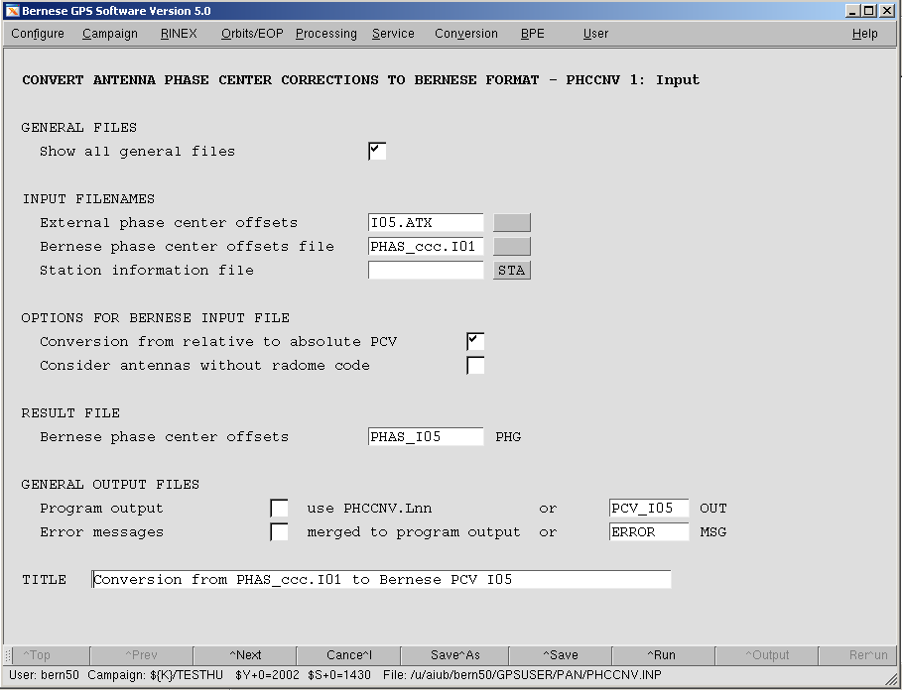

Handling of Antennas Without Radome Code
The new version of the converter forces the user to use antenna radome codes for all antennas as recommended by the new IGS policy. For antennas read from the input Bernese PCV file with blank radome code (last four characters in the antenna name), this code is replaced by a string ’????’. The user then has to check the output Bernese PCV file and insert the correct radome codes. By disabling the option "Consider antennas without radome code", antennas without radome code are not written to the output file. In any case, check carefully the antenna names in the input Bernese PCV file, insert missing antenna radome codes and assure consistency with the station information file before starting the conversion. After the conversion, check the detailed output of program PHCCNV that indicates how each individual antenna was handled. If necessary, repeat the procedure.

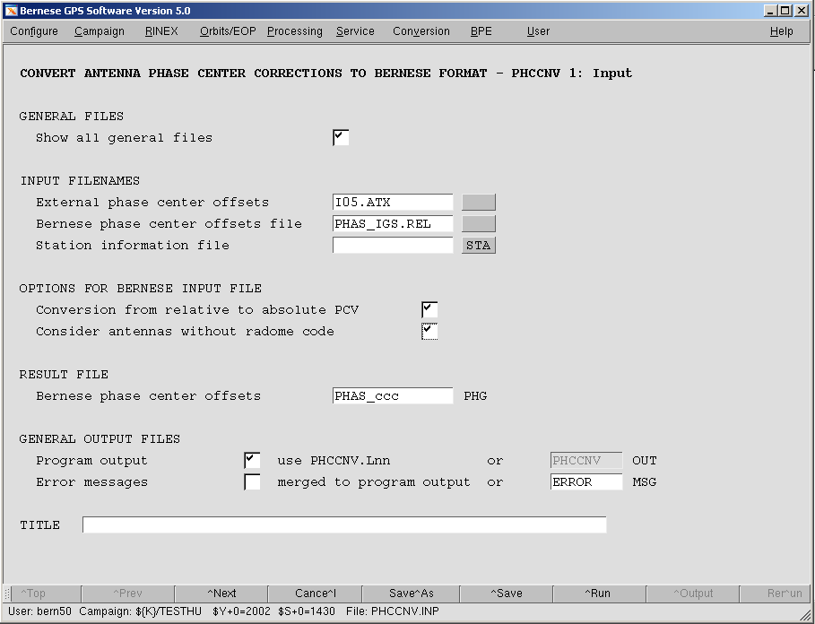

Routinely Running PHCCNV
For permanent network analysis, users of the Bernese Software are advised to download the SATELLIT.xxx file (xxx=I01 or I05) on a regular basis (either from ftp://ftp.unibe.ch/aiub/ BSWUSER50/GEN or from http://www.aiub.unibe.ch/ download/BSWUSER50/GEN). When using SATELLIT.I01 and in particular SATELLIT.I05, updating your PHAS_ccc.xxx file in a BPE process becomes indispensable in order to avoid aborting of your processing. The main reason for that is to keep the satellite-specific PCV entries up to date in your PCV file (e.g. with respect to brand new satellites), see Section 1.1.3.
A nice side effect of such an update step is that PCV calibrations of added receiver antenna/radome combinations get automatically included in your PCV file. This obviously also includes indicated "enlargement" of your PCV file (after a change of your STA info file). It is worth mentioning that the PCV model identifier gets automatically updated, ensuring proper PCV model declaration in your SINEX results (see Section 3.1.5).
For this purpose, the files I01.ATX and I05.ATX are maintained at CODE (in terms of the GPS/GLONASS satellite constellation) and regularly posted to the addresses mentioned above. Both files should be consistent to igs_01.atx and igs05_wwww.atx (latest version: igs05_1365.atx), respectively, which are maintained at the IGS CB (in terms of the IGS receiver network).

Problematic Antenna Radome Combinations in Relative Case
There are four antenna/radome combinations for which relative PCV calibrations are included in I01.ATX:
ASH701945E_M SCIS
LEIAT504 LEIS
TPSCR3_GGD CONE
NOV503+CR SPKE
Please be aware of the fact that after the conversion in the relative case (Section 3.2.1) your data analysis will be based on a different PCV model for these antennas (antenna radome codes are considered after the conversion). If you want to use the PCV values of the corresponding NONE antenna, you have to remove the calibration entries from the input ANTEX file (I01.ATX) before executing the conversion.

Also, note that there are antennas for which different PCV values are in circulation. Examples are:
LEIAT303
LEIAT504.
This list is not complete.

How to Switch to the New File Formats
The following sections describe the procedures to generate and implement the new relative and absolute satellite information resp. phase pattern files into your processing. The steps described in Section 4.1 may be done at any time while the switch to absolute antenna phase patterns described in Section 4.2 should be performed together with IGS's switch to absolute patterns, foreseen in autumn 2006.

Switch from Currently Used Old PCV File to New Relative File
You are currently using a version of the Bernese PCV file that contains relative antenna information and a corresponding satellite information file. Both files can be downloaded from our anonymous ftp server (ftp://ftp.unibe.ch/aiub/BSWUSER50/GEN or http://www.aiub. unibe.ch/download/BSWUSER50/GEN) with the names PHAS_IGS.REL and SATELLIT.
These files have to be updated before switching to absolute PCVs, i.e., you have to perform a switch from relative PCV(old) to relative PCV(new). Switching to the new relative file is just a preparation for the upgraded program PHCCNV and the upcoming absolute antenna model. Apart from the impact of the few receiver antenna radome combinations additionally included in I01.ATX (see Section 3.4) no changes in the analysis results are expected.
The differences in the relative set of files to the files you are currently using concern:
- the satellite antenna names and
- radome codes for all receiver antennas (most of them with NONE).

To use these files the following steps have to be performed:
- Download the file SATELLIT.I01 from URL "http://www.aiub.unibe.ch/download/ BSWUSER50/GEN" and put it into the $X/GEN directory (%X%\GEN for windows).
- Change in your station information file the last four characters of the antenna names in the second section (TYPE 002) from blank to the correct antenna radome code (e.g., NONE, DOME, SNOW etc.).
You may either use an ASCII editor or the menu: Campaign >Edit station files >Station information.
- Add correct antenna radome codes, e.g., NONE or DOME to the antenna names in your Bernese PCV file (last four characters).
- Run the ANTEX converter PHCCNV as described in the example in Section 3.2.1. Use the ANTEX file I01.ATX (downloaded from AIUB and stored in the campaign's OUT directory), the SATELLIT.I01 satellite information file, your Bernese PCV file, as well as your station information file as input. You may use Conversion >ANTEX to Bernese format.
- Check carefully the program output and verify the output of the new relative Bernese PCV file generated in the campaign's OUT directory. Correct your input files and repeat the program run if you identify problems or copy the output PCV file to the $X/GEN directory (%X%\GEN for Windows) if you are satisfied with the result. Select a file name such as, e.g., PHAS_ccc.I01 where ccc identifies your institution.
- Activate option "consider radome codes of the antennas" in panel "RXOBV3 4" of the RINEX converter. It is important that after the switch to the new file format all Bernese observation files contain the proper receiver antenna/radome code combinations.
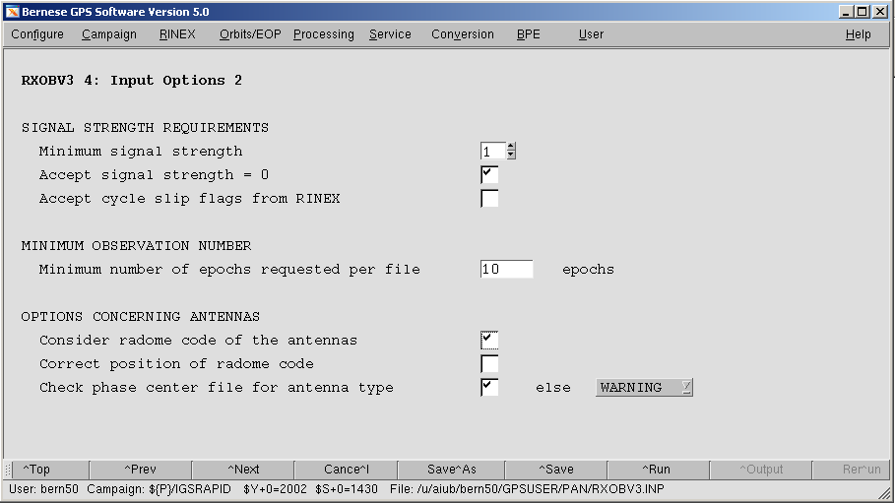

- If necessary adapt header information in already existing Bernese observation files with the edited station information file from the previous step as input. You may use the menu: Service >Bernese observation files >Change header information.
- Change the names of the satellite information file in all program panels from SATELLIT. to SATELLIT.I01 and of the Bernese PCV file from PHAS_IGS.REL (or own file name) to PHAS_ccc.I01 (or own file name).
You may use the menu: Configure >Change general options.
Perform this step for $U/PAN as well as for $X/PAN.
- Use for the BPE the variable $(PCV) as described in Section 2.2. Set the value of the variable to I01 in the PCFs.
Instead of using the file PHAS_ccc.I01 generated by the steps described above you may also download the Bernese PCV file PHAS_COD.I01 from URL "http://www.aiub.unibe.ch/ download/BSWUSER50/GEN". But be aware that this file does not contain your individually calibrated antennas and may lack more antennas you need for your processing. The CODE team added the most commonly used antenna radome combinations to the Bernese PCV file (PHAS_COD.I01) by copying the PCV values of the corresponding NONE antenna (e.g., values for "AOAD/M_T SCIS" copied from "AOAD/M_T NONE"). Nevertheless it is probable that some antenna radome combinations are not included.

Switch from Relative Files to Absolute Files
For switching from relative to absolute PCV file the steps described in Section 4.1 have to be performed first. The differences in the absolute set of files to the relative set of files concern:
- satellite specific Z-offsets,
- absolute satellite and receiver antenna PCV, and
- much more calibrated antenna radome combinations.

To use these files the following steps have to be performed:
- Download the file SATELLIT.I05 from URL "http://www.aiub.unibe.ch/ download/BSWUSER50/GEN" and put it into the $X/GEN directory (%X%\GEN for windows).
- Use the station information file from the conversion step described Section 4.1, if it is already prepared for the converter PHCCNV. Otherwise change the last four characters of the antenna names in the second section of the file from blank to the correct antenna radome code (e.g., NONE, SCIS, SNOW etc.).
You may either use an ASCII editor or the menu: Campaign >Edit station files >Station information.
- Run the ANTEX converter PHCCNV as described in the example in Section 3.2.6. Use the ANTEX file I05.ATX (downloaded from AIUB and stored in the campaign's OUT directory), the SATELLIT.I05 satellite information file, your Bernese PCV file, as well as your station information file as input. You may use Conversion >ANTEX to Bernese format.
- Check carefully the program output and verify the output of the new relative Bernese PCV file generated in the campaign's OUT directory. Correct your input files and repeat the program run if you identify problems or copy the output PCV file to the $X/GEN directory (%X%\GEN for Windows) if you are satisfied with the result. Select a file name such as, e.g., PHAS_ccc.I05 where ccc identifies your institution.
- Activate option "consider radome codes of antennas" in panel "RXOBV3 4" (see figure in Section 4.1) if not already activated.
- If necessary adapt header information in existing Bernese observation files with the edited station information file from the previous step as input. You may use the menu: Service >Bernese observation files >Change header information.
Note that relative NEQ-files cannot be converted to the absolute case by manipulating them with the help of the new absolute set of files. For a consistent reprocessing with absolute antenna information you have to start at least with existing observation files.
- Change the names of the satellite information file in all program panels from SATELLIT.I01 to SATELLIT.I05 and of the Bernese PCV file from PHAS_ccc.I01 (or own file name) to PHAS_ccc.I05 (or own filename).
You may use the menu: Configure >Change general options. Perform this step for $U/PAN as well as for $X/PAN.
- For BPE use the variable $(PCV) as described in Section 2.2. Set the value of the variable to I05 in the PCFs.

Instead of generating the file PHAS_ccc.I05 you may download the Bernese PCV file PHAS_COD.I05 from URL "http://www.aiub.unibe.ch/download/BSWUSER50/GEN". But be aware that this file does not contain your individually calibrated antennas and may also lack other antennas that you require for your processing. The CODE team added the most commonly used antenna radome combinations to the Bernese PCV file (PHAS_COD.I05) by copying the PCV values of the corresponding NONE antenna (e.g., values for "AOAD/M_T SCIS" copied from "AOAD/M_T NONE"). Nevertheless it is probable that some antenna radome combinations are not included.

Routinely Updating Phase Pattern File
The Bernese PCV file has to be regularly updated, e.g., if a new satellite is launched and corresponding pattern and antenna offset information is needed (see Section 1.1.3), if the IGS ANTEX file igs05_wwww.atx is updated with new antennas, or if you want to add own, individually calibrated antennas. The update procedure is very simple:
- Download the necessary files SATELLIT.I05 and I05.ATX (synchronized by AIUB/CODE with the corresponding IGS ANTEX file) from URL "http://www.aiub.unibe.ch/ download/BSWUSER50/GEN" and put the first file into the $X/GEN directory (%X%\GEN for windows), the second into the OUT directory of your campaign.
- Run the ANTEX converter PHCCNV as described in the example in Section 3.2.1 or 3.2.5. Use the ANTEX file I05.ATX or the ANTEX file containing your individually calibrated antenna values, the SATELLIT.I05 satellite information file, your Bernese PCV file, as well as your station information file as input. You may use Conversion >ANTEX to Bernese format.
- Check carefully the program output and verify the output of the new relative Bernese PCV file generated in the campaign's OUT directory. Copy the output PCV file to the $X/GEN directory (%X%\GEN for Windows) if you are satisfied with the result. Select a file name such as, e.g., PHAS_ccc.I05 where ccc identifies your institution.
- If you generated a PCV file with a new name PHAS_ccc.I05, replace the old name by the new name in all program panels, including BPE option directories. You may use the menu: Configure >Change general options. Perform this step for $U/PAN as well as for $X/PAN and $U/OPT. Because the file contains the model name we recommend to keep the same filename.
It is recommended to perform these steps on a regular basis, e.g., using a BPE-based procedure as described in Section 3.3.

Summary of File Names
The following table summarizes the file names referring to the different status, 0: current status of relative PCV information, 1: status after update to new file format (satellite antenna names) but still relative as described in Section 4.1, 2: status after switch to absolute antenna PCV information as described in Section 4.2.
Status | Satellite information | Model name | CODE ATX | Bernese PCV
0 | SATELLIT. | IGS_01 | – | PHAS_ccc.REL (or PHAS_IGS.REL)
1 | SATELLIT.I01 | IGS_01 | I01.ATX | PHAS_ccc.I01
2 | SATELLIT.I05 | IGS05_wwww | I05.ATX | PHAS_ccc.I05

The four character string ‘wwww’ refers to the GPS week in which IGS issues a new absolute PCV model (new receiver or satellite antennas included), ‘ccc’ designates, e.g., the institution maintaining the PCV information. The PCV model name is transferred from the Bernese PCV file title header into the SINEX file written by ADDNEQ2. Files SATELLIT.xxx and xxx.ATX with xxx=I01 and I05 are maintained by AIUB/CODE and should be downloaded regularly. Files PHAS_COD.xxx are made available by CODE. Make sure to never mix PCV and satellite information files referring to relative and to absolute PCV information.

